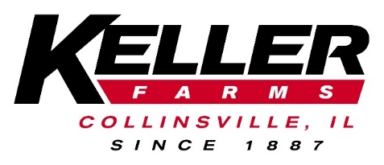
Keller Farms is a large family-owned farming operation near Collinsville, Illinois and Charleston, Missouri. The farm produces a variety of grain and specialty crops such as horseradish and sweet corn. We take an aggressive approach to maintaining soil fertility, controlling weeds and insects, providing added plant nutrients, preparing seedbeds, cultivating, and harvesting to maximize commodity production.
Keller Farms is looking to hire an individual who is energetic and eager to join our expanding farming operation. This position is a full-time position offering a competitive benefits’ package as well as offering room for advancement. This job will require, but not limited to, the following:
Farm Operator/Technician
Responsibilities:
- Assist with all farming operations such as operating farm equipment, planting, irrigation, harvest and shipments.
- Ensure efficient use and care of all equipment.
- Perform routine maintenance on equipment
- Direct and monitor the activities of crews
Requirements:
- Previous experience in farming, agriculture, or related field required.
- Knowledge of Electrical, hydraulic, and mechanical system repairs and basic diagnosis
- Experience operating large farm equipment and implements.
- Welding experience
- Ability to work independently, as well as part of a team
- Maintain complete and accurate records
- Willingness to learn
- Availability to have a flexible work schedule
- Valid driver’s license
A Class-A CDL and Applicators License is preferred, but not required.
Benefits:
- Health Insurance
- 401K with company match
- Vacation and Holiday pay
- Bonus/Profit sharing
- Uniforms

